Nalongsone Danddank Student ID : 14958950 StarID: jf3893pd

Email: [nalongsone.danddank@my.metrostate.edu](mailto:nalongsone.danddank@my.metrostate.edu)\

**ICS 432 - 01 — Distributed and Cloud Computing Fall 2021**

**Lab #4 :** Elastic File System

Part 1: AWS Elastic File System (EFS).

**Lab report screen-shot #1:**

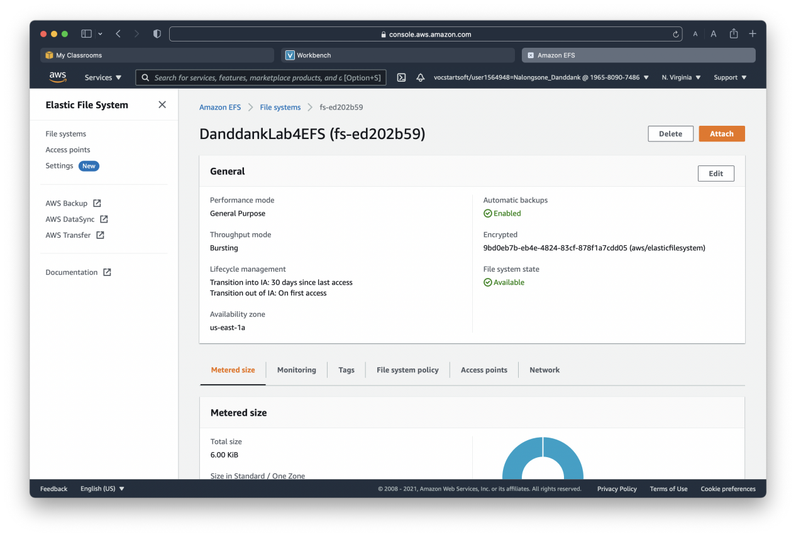

**Lab report screen-shot #2:**

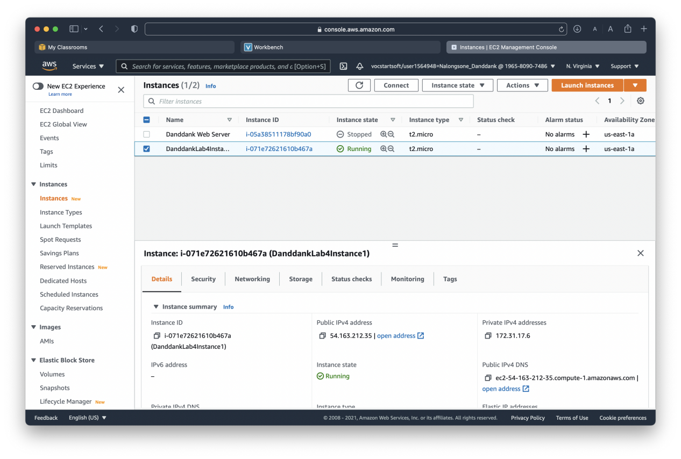

**Lab report screen-shot #3: Ignore**

**Lab report screen-shot #4:**

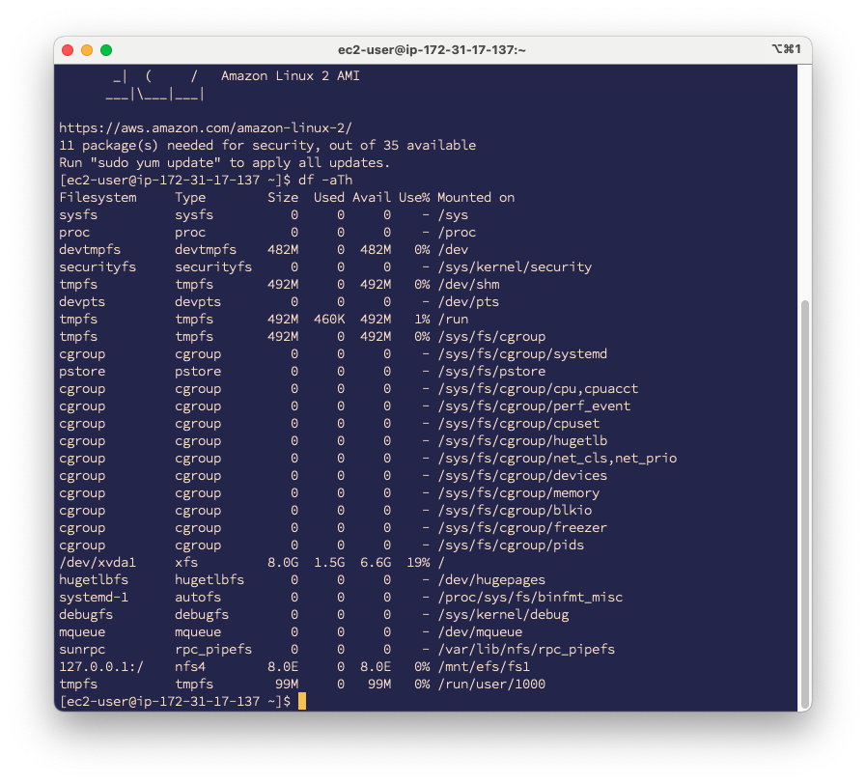

**Lab report screen-shot #5:**

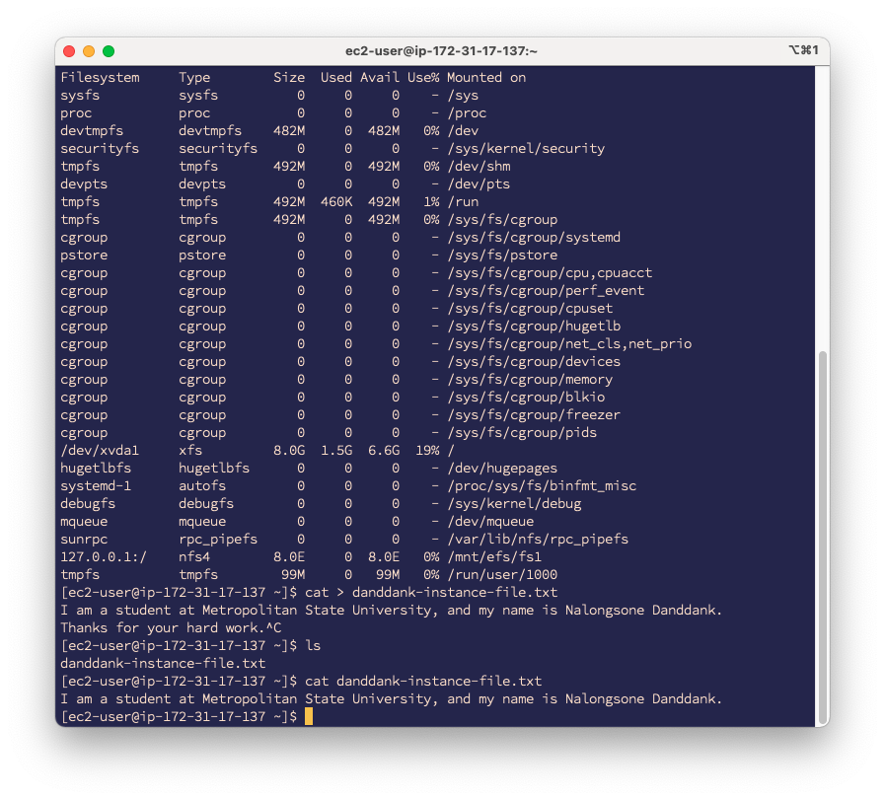

**Lab report screen-shot #6:**

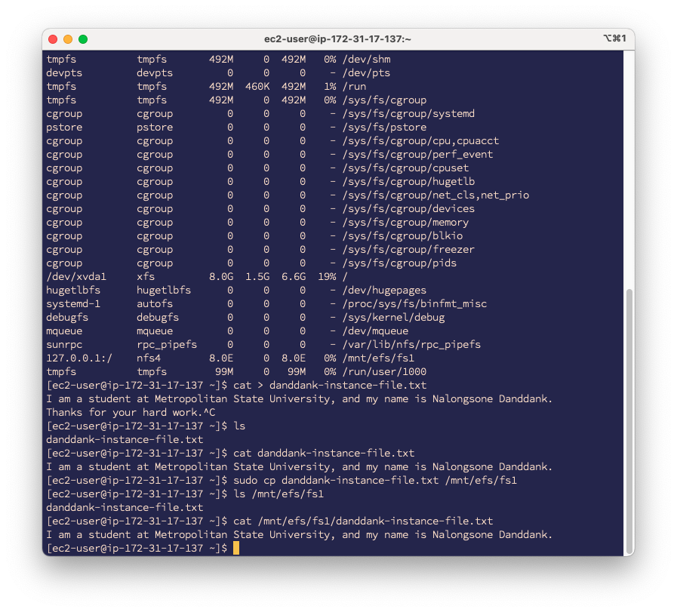

**Lab report screen-shot #7:**

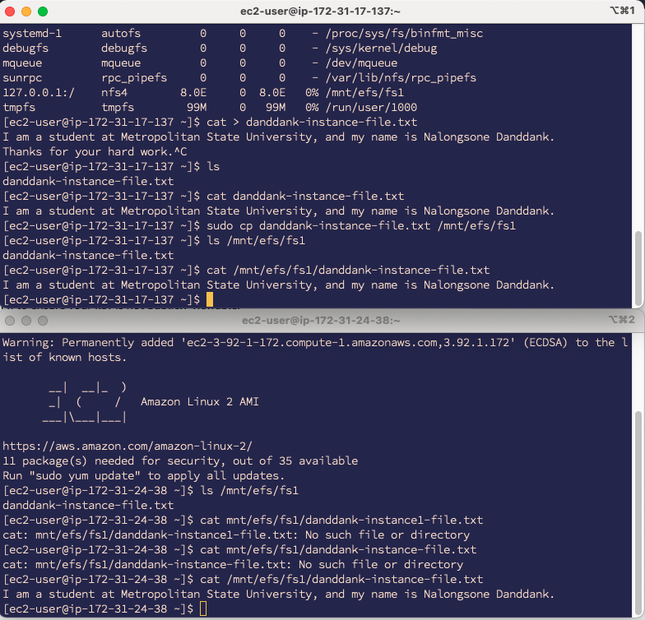

**Lab report screen-shot #8:**

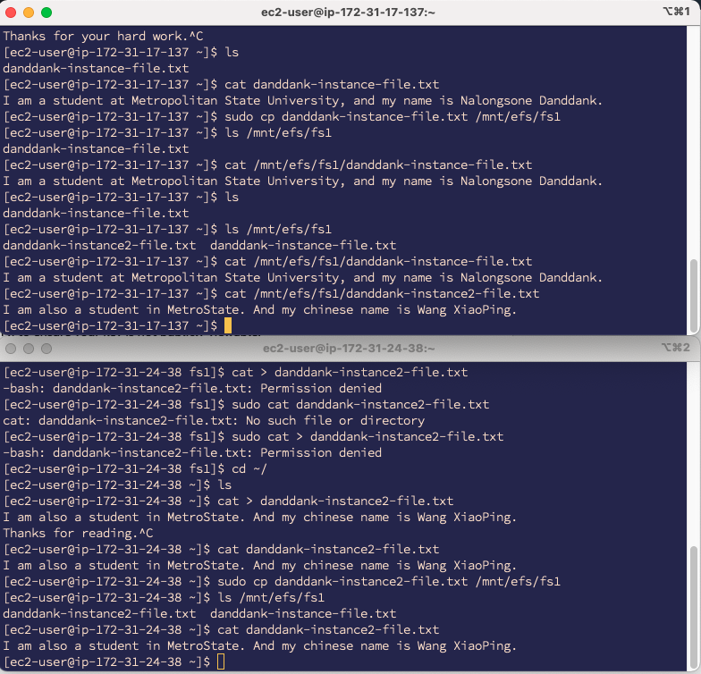

**Lab report screen-shot #9:**

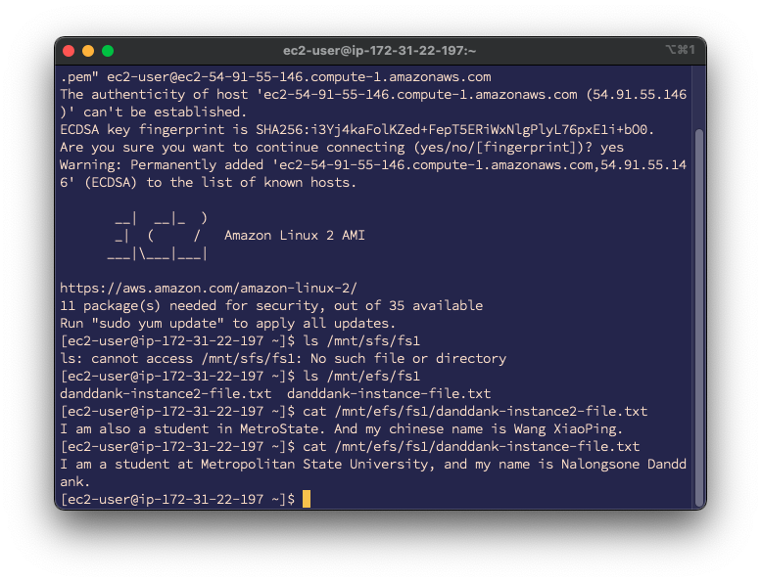

**Lab report screen-shot #10:**

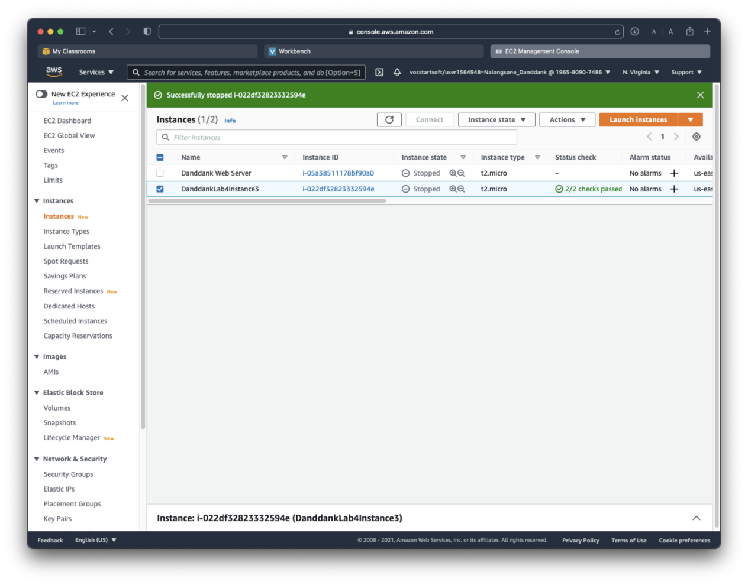

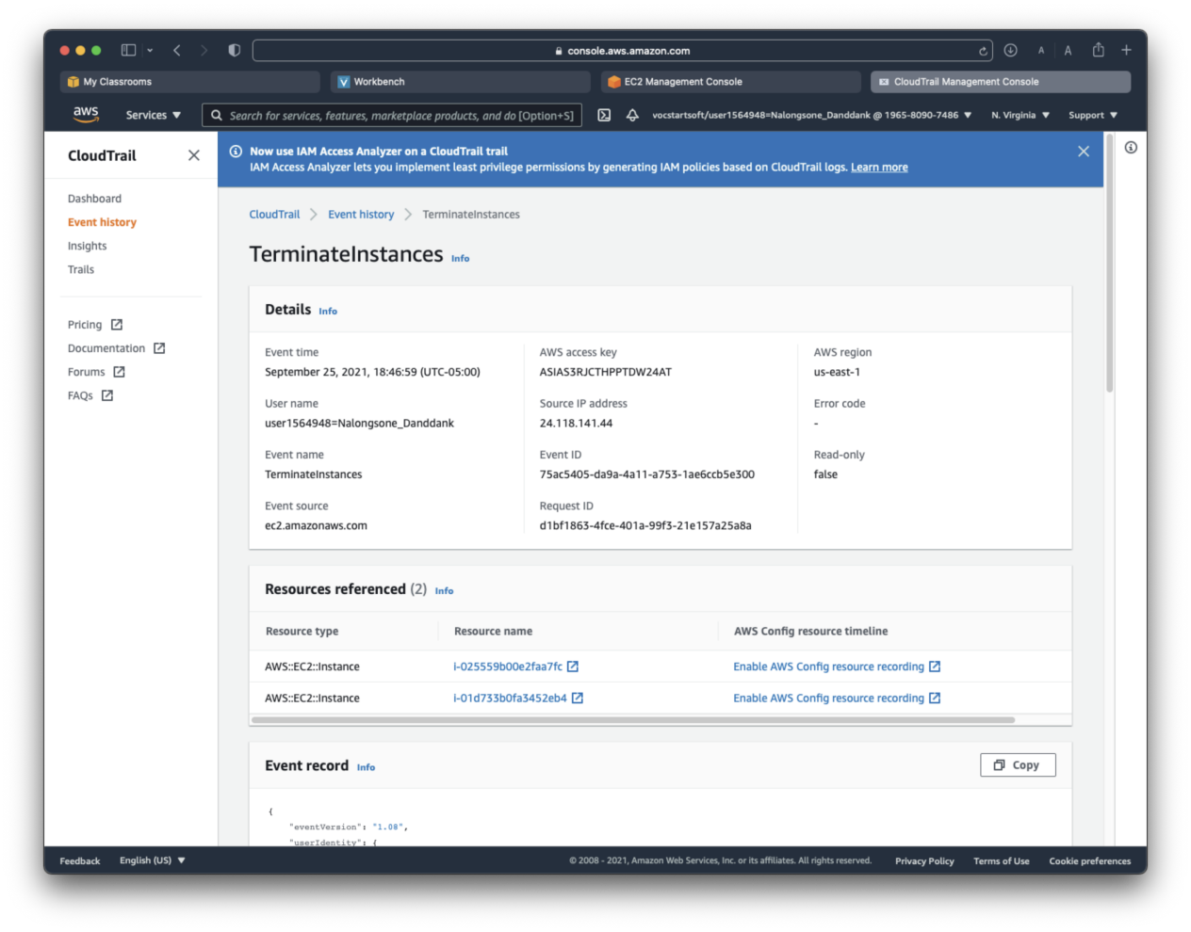

Part 2: GCP Cloud Filestore.

**Lab report screen-shot #11:**

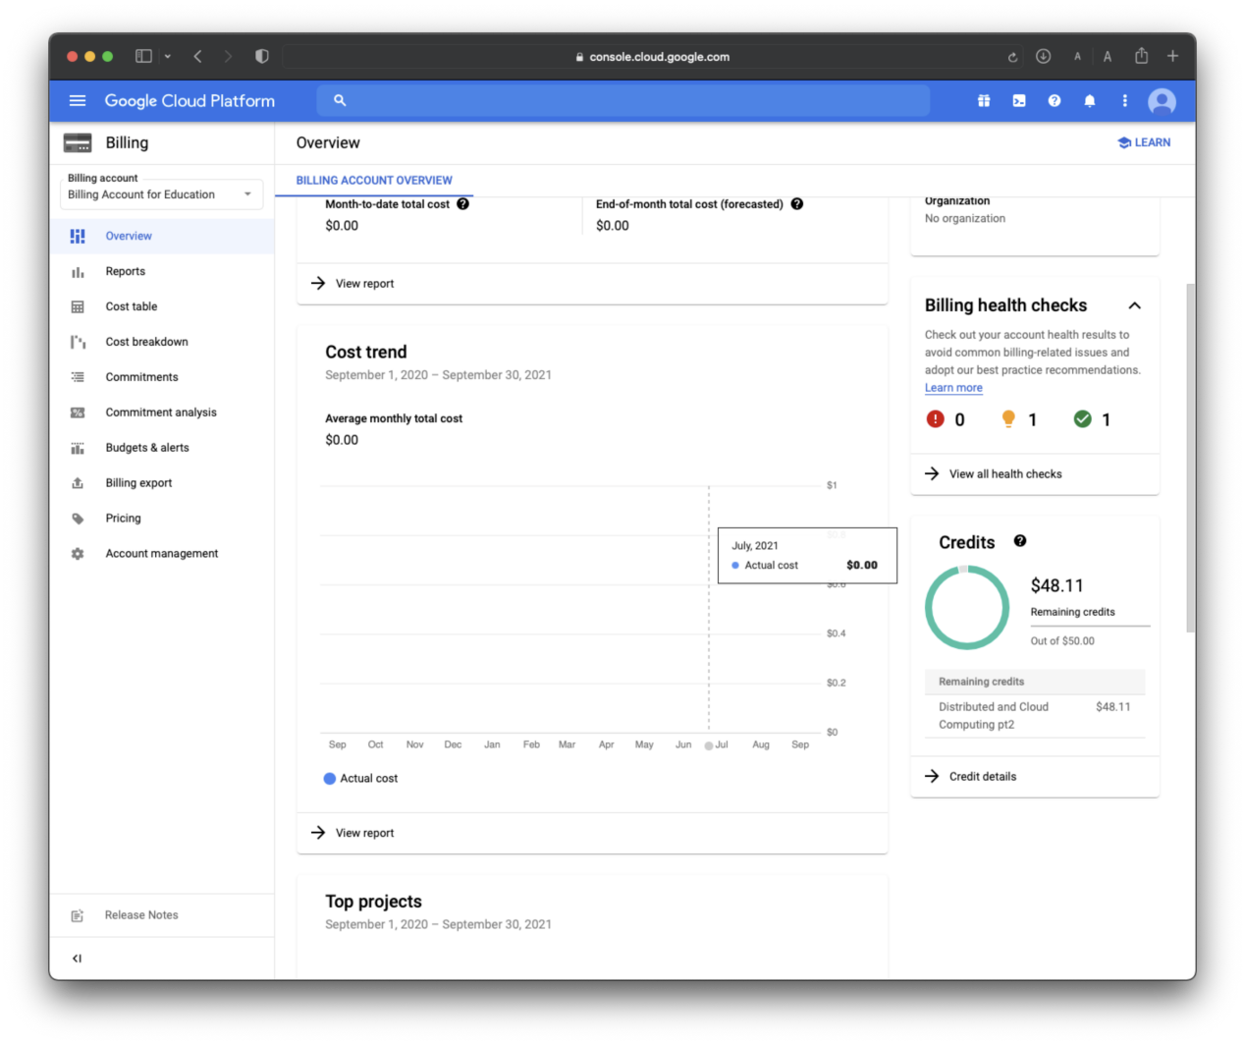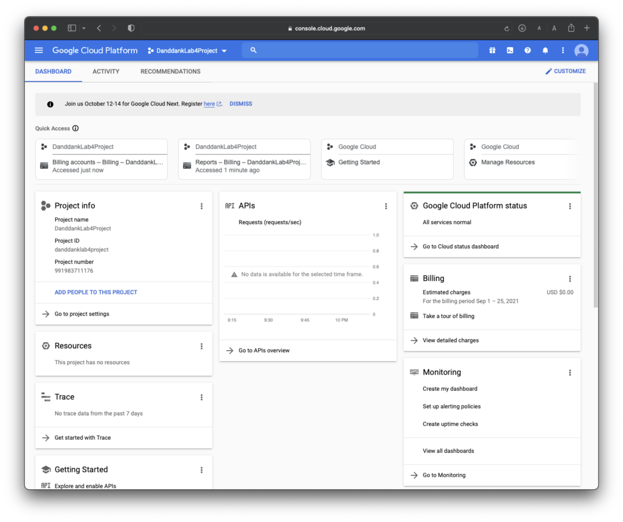

**Lab report screen-shot #12:**

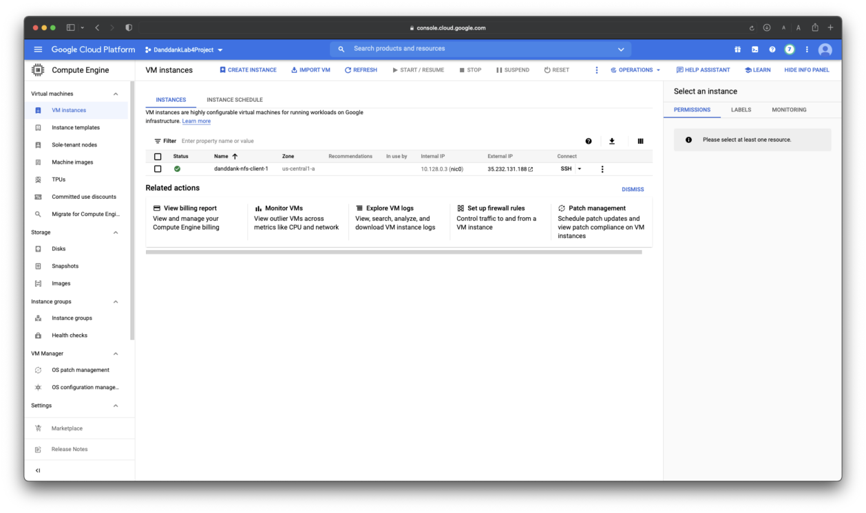

**Lab report screen-shot 13:**

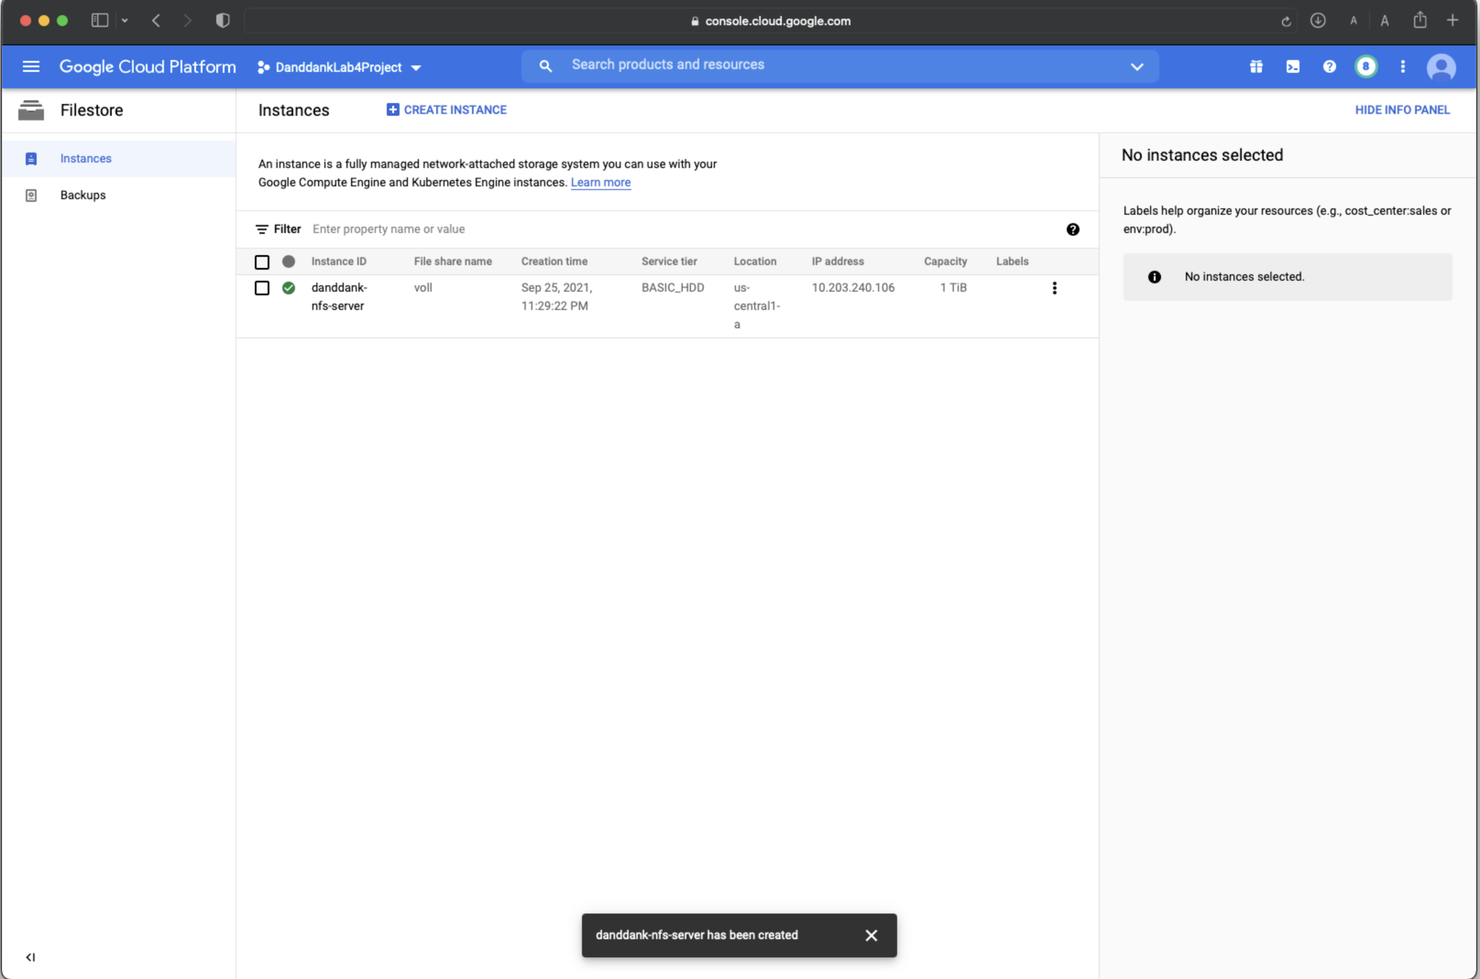

**Lab report screen-shot 14:**

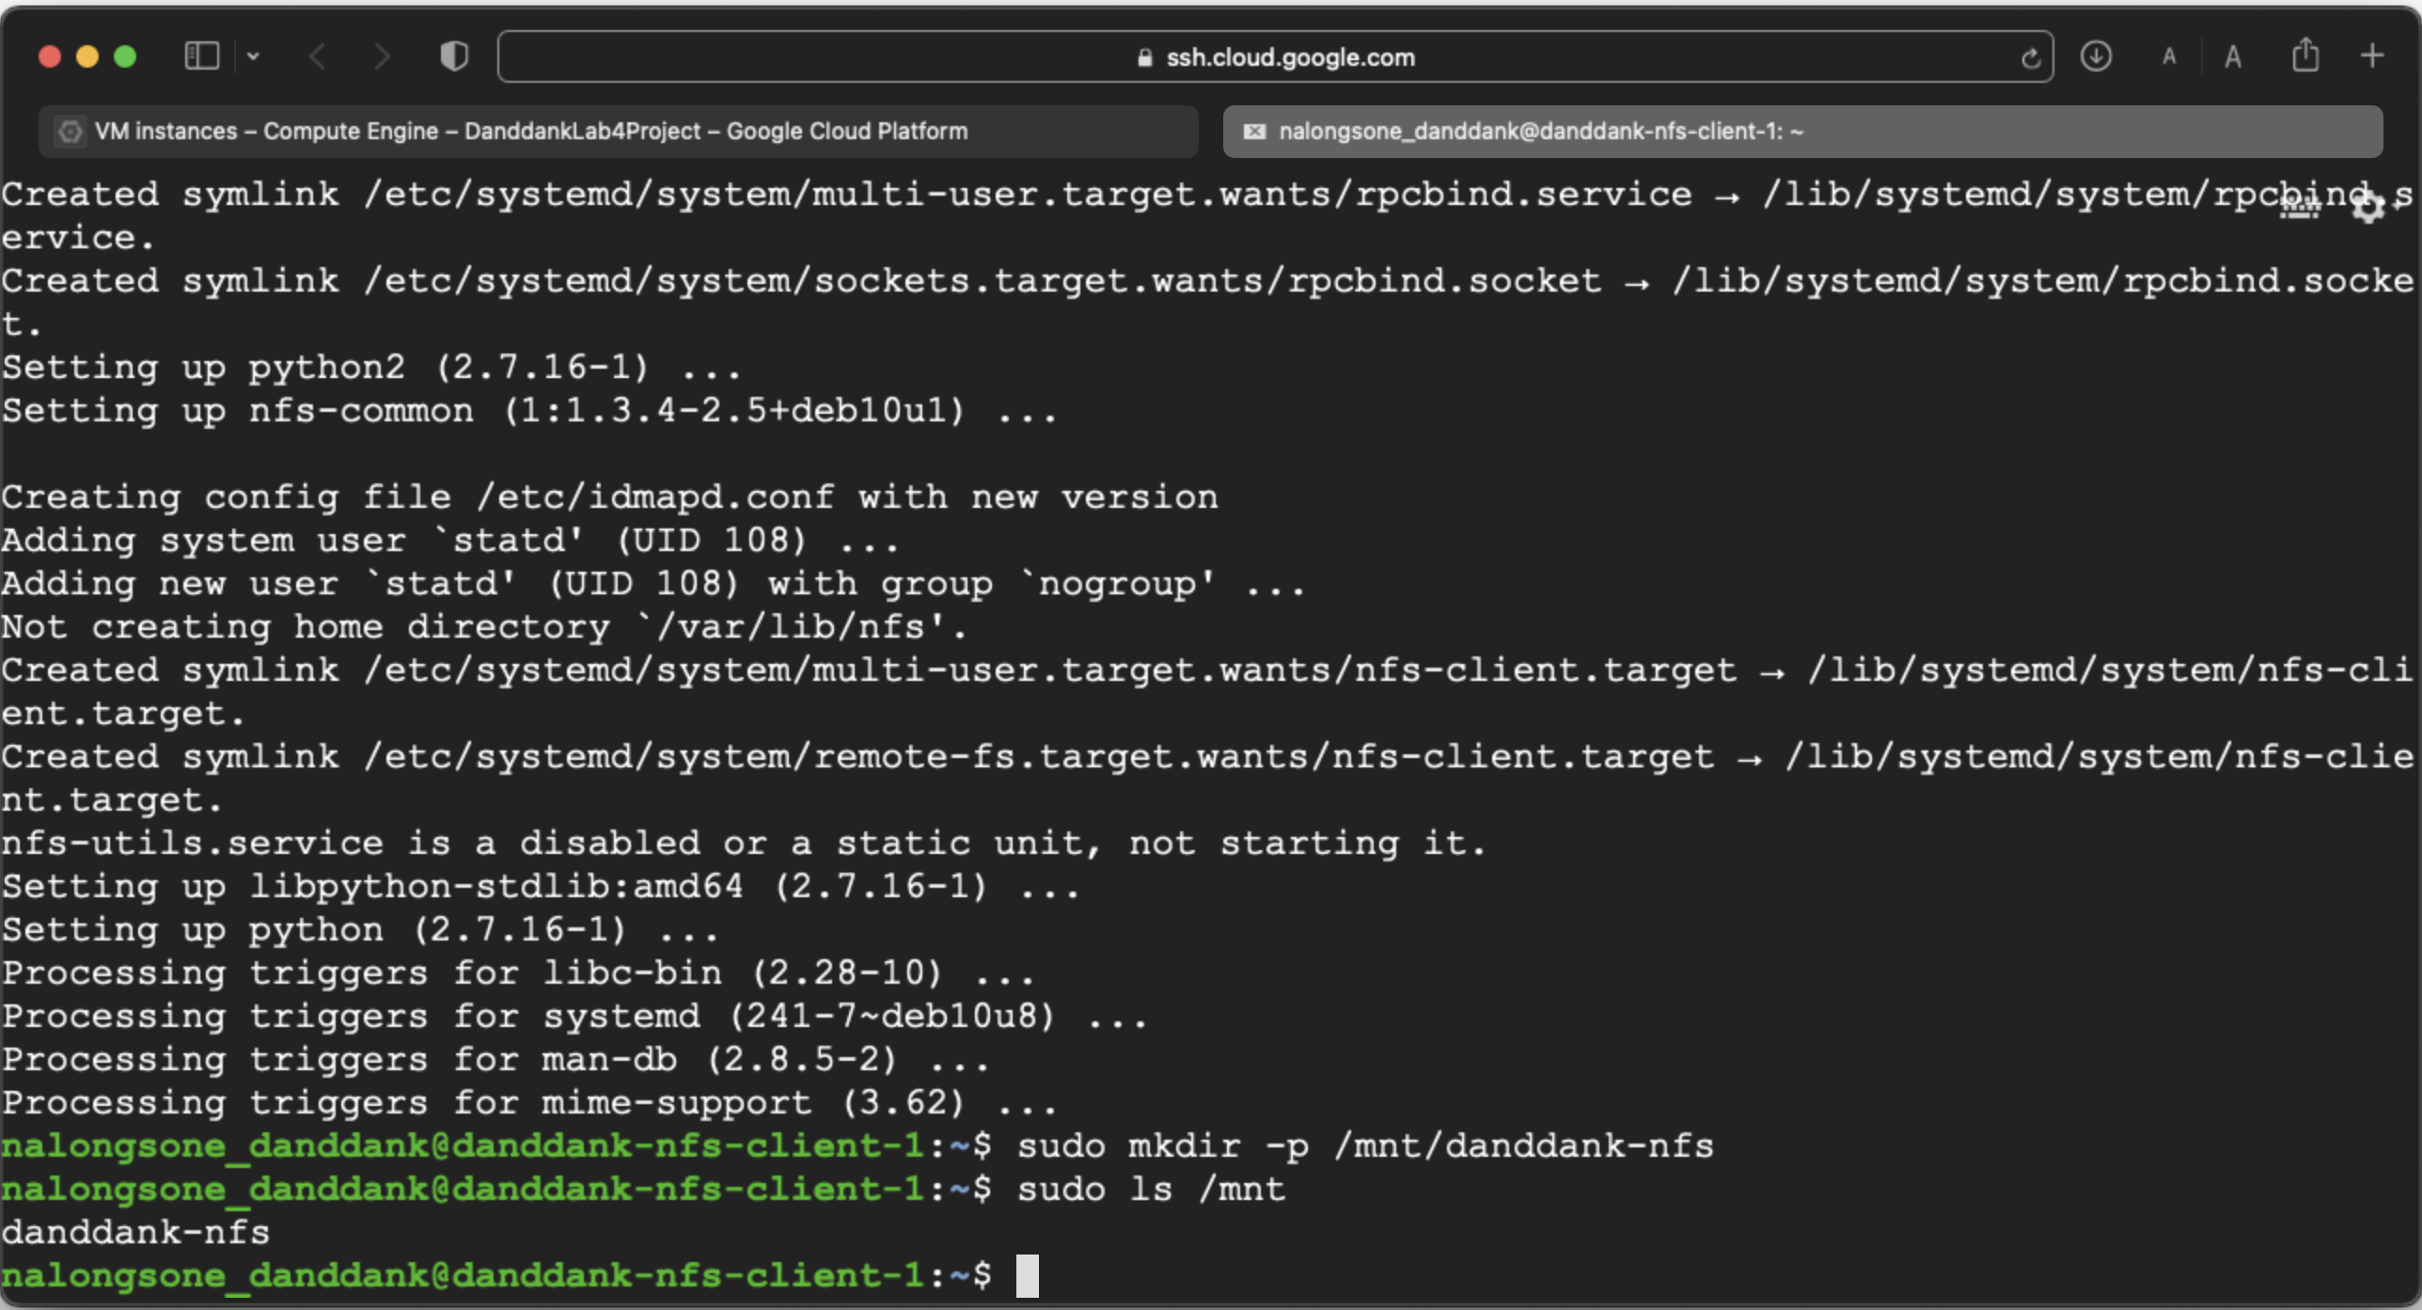

**Lab report screen-shot #15:**

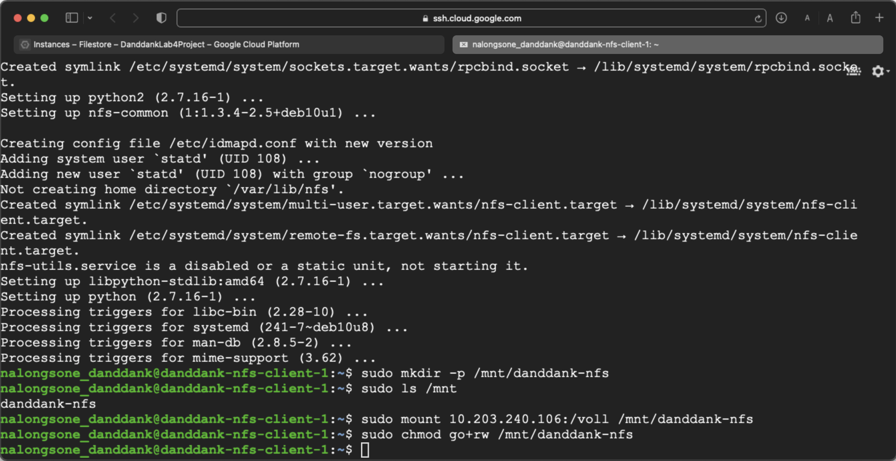

**Lab report screen-shot #16:**

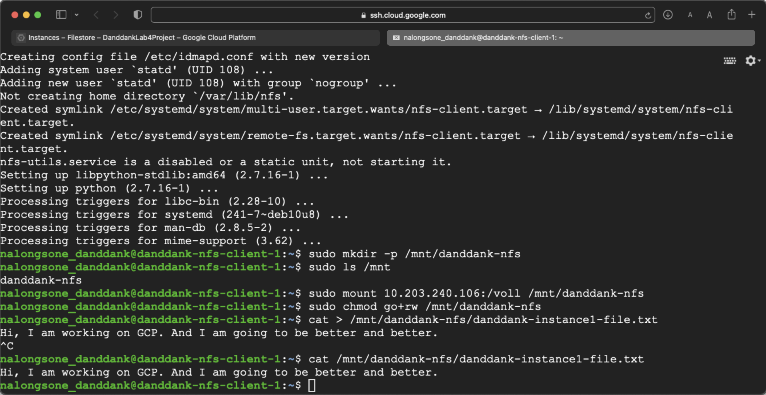

**Lab report screen-shot #17:**

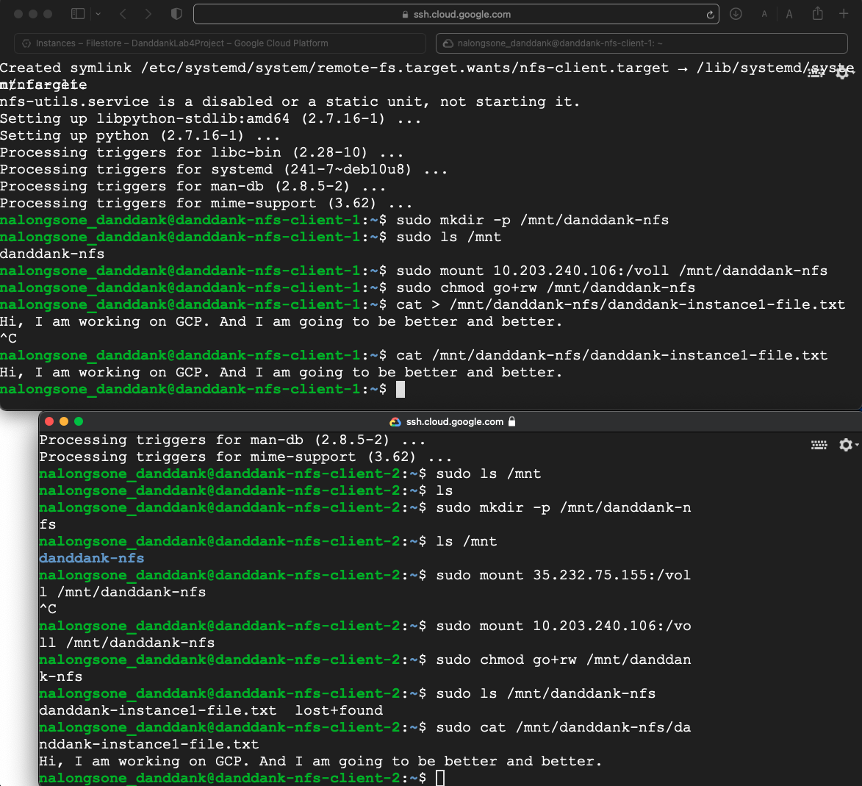

**Lab report screen-shot #18:**

